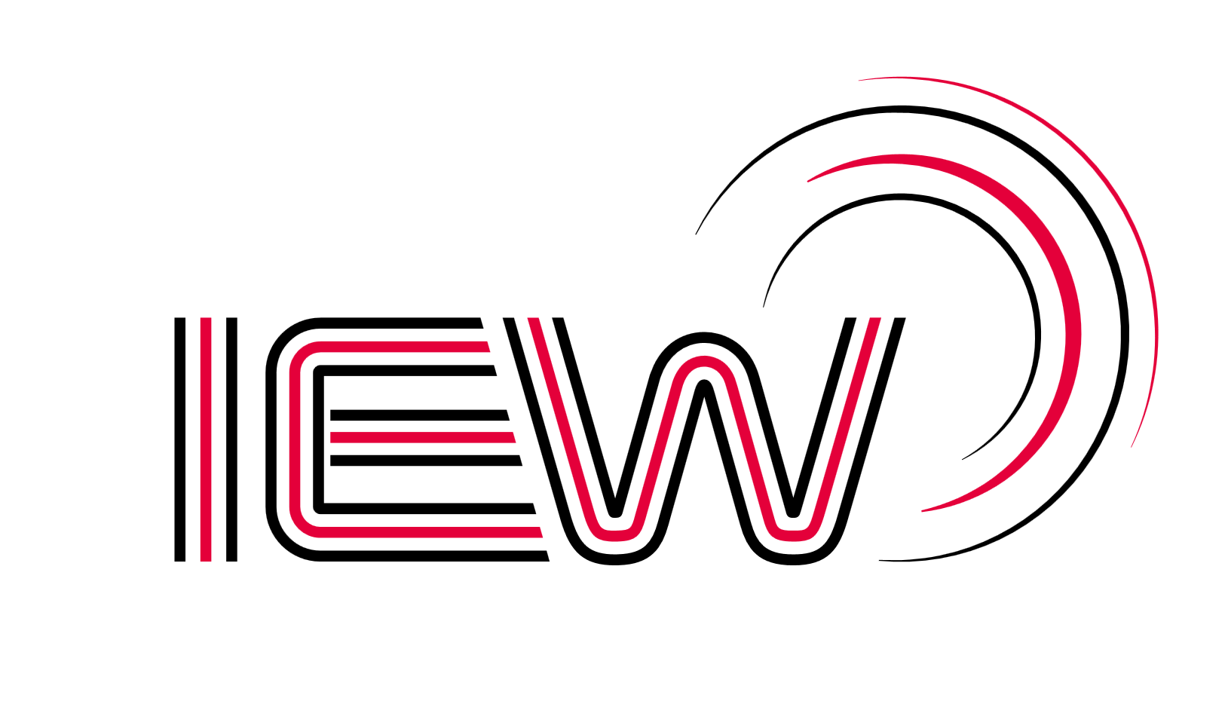

Industrial Electronic Wiring Ltd.

Conflict Materials Policy
The definition of “Conflict Material” refers to the minerals; tantalum, tin, tungsten, gold (3TG materials) from the Democratic Republic of the Congo (DRC) and adjoining countries (Angola, Burundi, Central African Republic, the Republic of the Congo, Rwanda, South Sudan, Tanzania, Uganda, and Zambia), which is known as the “Conflict Region”
With the increasing awareness of violence and human rights violations in the mining of these minerals from this location companies around the world have been requested to practice reasonable due diligence within their supply chain to assure that the specified metals are not being sourced from mines in the Conflict Region, which are controlled by non-government military groups, or unlawful military factions.
Industrial Electronic Wiring Ltd. supports this initiative and are committed to:
- Supporting the Dodd-Frank Wall Street Reform and Consumer Act and the rules laid down by the US Securities and Exchange Commission (SEC)

- Will not knowingly use material which has been derived from the “Conflict Region” that have not been certified as “Conflict free” such as the “Conflict Free Smelter Program”

- We will work closely with our supply chain in the continual support of this policy

- The implementation and control within the management system processes to ensure the continuation of this policy

